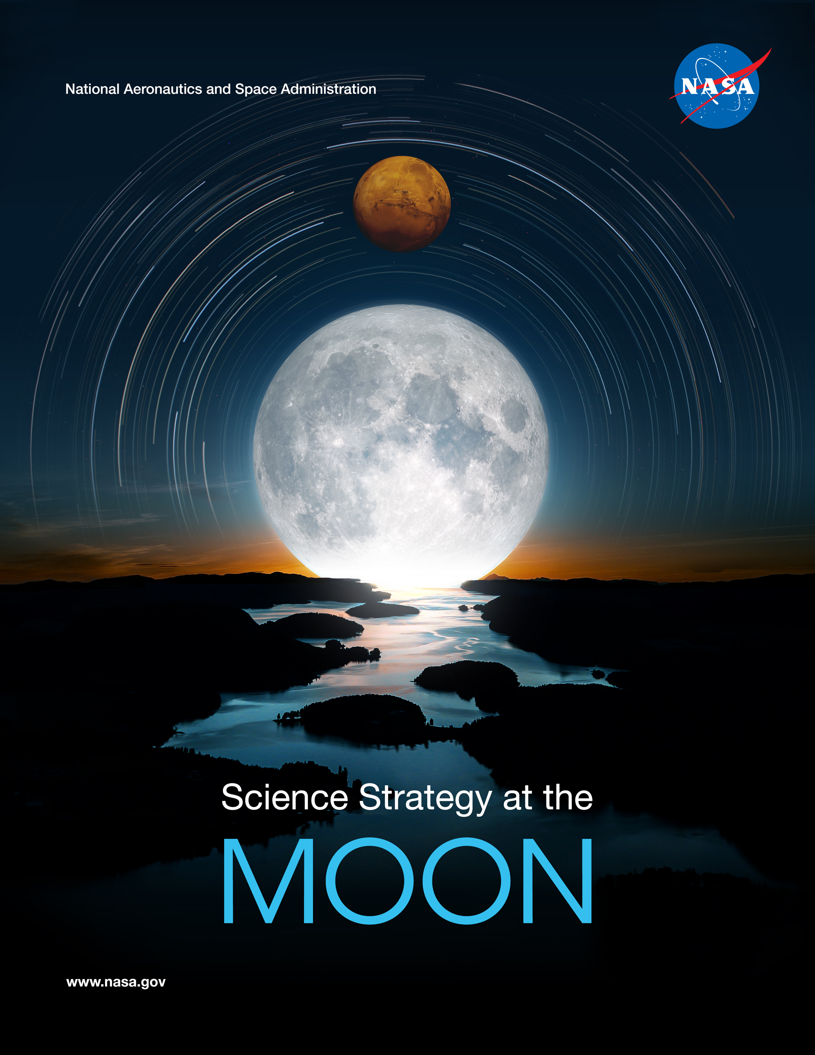
REP
Rev | By | Description | Date
- | B. Bussey | Baseline Release | 15 May 2019
A | B. Bussey | Updated with NAC comments and Exploration architecture updates | 13 March 2020
B | S Clarke & B Bussey | General editing and addition of a conclusion | 27 March 2020

“Fifty years ago, “one small step for man” became “one giant leap for mankind.” But now it’s come the time for us to make the next “giant leap” and return American astronauts to the Moon, establish a permanent base there, and develop the technologies to take American astronauts to Mars and beyond…. it is the stated policy of this administration and the United States of America to return American astronauts to the Moon within the next five years. And let me be clear: The first woman and the next man on the Moon will both be American astronauts, launched by American rockets, from American soil.
“ –Vice-President Pence, March 26, 2019

Overview
On December 11, 2017, the president signed Space Policy Directive 1 (SPD-1), a change in national space policy that provides for a U.S.-led “innovative and sustainable program of exploration with commercial and international partners to enable human expansion across the Solar System and to bring back to Earth new knowledge and opportunities.” The effort will more effectively organize government, private industry, and international efforts toward returning humans to the Moon, and will lay the foundation that will eventually enable human exploration of Mars.

The stated policy of the United States is to return humans to the surface of the Moon by 2024, and this effort has been named Project Artemis. As outlined by the Lunar Exploration Analysis Group’s “Advancing Science of the Moon” report in 2018, “The Moon is a resource-rich, readily accessible target for future United States human and robotic missions that will enable fundamental scientific advances impacting our understanding of the Solar System”.

Beginning in 1994, with the launch of the Clementine mission, numerous lunar missions from the United States and other countries have been flown. Each of these missions has produced significant advances in our understanding of planetary processes, uncovered new planetary science questions, defined key locations for future exploration, and collected sufficient data to enable safe landings across the lunar surface. Exploring the Moon has immense scientific value, and SMD will play an important role in Project Artemis.

NASA Science Role for Artemis
For NASA, this policy provides critical strategic guidance for investments in human exploration, and technology investment, but also creates opportunity for NASA Science in three ways
- NASA Science will lead the way to the Moon through an innovative program enabled by commercial companies: the Lunar Discovery and Exploration Program.
- NASA Science will benefit from science opportunities enabled by investments in human exploration, such as infrastructure associated with human exploration including the Gateway in lunar orbit and regular crewed missions to the lunar surface.
- Discoveries from NASA Science investigations will help safeguard the journey to the Moon and beyond through providing information about the Moon and environmental constraints during the journey, including space weather.

Lunar Discovery and Exploration Program
To achieve an innovative and sustainable program of scientific and human exploration with commercial and international partners, NASA created the Lunar Discovery and Exploration Program (LDEP) in the Science Mission Directorate (SMD) led by the Deputy Associate Administrator for Exploration (DAAX). The LDEP portfolio includes the Commercial Lunar Payloads Services (CLPS) contract for lunar landing transportation services; the development of lunar science instruments; the development of lunar SmallSats; continued operations of the Lunar Reconnaissance Orbiter; and investment in long-duration lunar rovers, The payloads and services enabled by the LDEP will address the nation’s lunar exploration, science, and technology demonstration goals. The DAAX Office, named the Exploration Science Strategy and Integration Office (ESSIO), integrates and coordinates the Artemis sciences efforts across the SMD divisions, across NASA directorates, and with other US and international agencies.

Leveraging the capabilities enabled by the Gateway and the Human Landing System, NASA Science will provide critical support for the safety of our astronauts as they conduct exploration activities in deep space. On-going efforts of the space weather research and operational communities, forecasting and nowcasting capabilities will be expanded to ensure humans have the necessary situational awareness of potentially hazardous space weather events.

In addition to the Decadal Survey, the Committee on Astrobiology and Planetary Science (CAPS) released two reports in February 2019 that provided findings and conclusions concerning NASAs plans for achieving the lunar science and exploration goals associated with SPD-1 and how new commercial ventures could provide “realistic opportunities to address meaningful lunar science and exploration objectives”.

The CAPS concluded that the LDEP is aligned with the decadal priorities and the portfolio “is a welcome development that has the potential to greatly benefit lunar science and could evolve into a program with large science return”.

Community Driven Science
The Moon is a scientifically rich location, and LDEP’s efforts and priorities will be driven by the US science community. The scientific opportunities represented by the Moon have been captured in a multitude of community documents such as:
  - Lunar Exploration Roadmap (2013) - Lunar Exploration Analysis Group (LEAG)
  - Astrophysics (2010) and Planetary (2013) Decadal Surveys - National Academies of Sciences, Engineering and Medicine (NASEM)
  - Scientific Context for the Exploration of the Moon (2007) - NASEM
  - Science White Paper (2018) - International Space Exploration Coordination Group (ISECG)
  - Advancing Science of the Moon (2018) - LEAG
  - Lunar Science Workshop Report - NASA Advisory Council, 2007 Tempe Workshop
  - Strategic Knowledge Gaps - NASA Human Exploration and Operations Mission Directorate

Community-developed documents such as these are what guides ESSIO to determine the LDEP science priorities and activities.
It is important to stress that access to the lunar surface enables science in a plethora of disciplines, not just lunar and planetary science. The broad science themes include the:
- Study of planetary processes
- Study of lunar volatile cycles and exploration of the utility of lunar resources for human exploration
- Impact history of the Earth-Moon system
- Use of the Moon as a unique platform to study the Universe
- Study of the Moon as a record of the ancient Sun
- A place for fundamental science in the lunar environment

Study of Planetary Processes
The Moon has experienced many of the processes that shape the terrestrial planets, e.g. large-scale differentiation, impacts, volcanism. These key planetary processes are manifested in the diversity of lunar crustal rocks. The Moon is therefore an accessible laboratory for the study of these processes, with a key factor being the collection and return of new lunar samples.

Study of Lunar Volatiles Cycles and Utility of Lunar Resources
Work in the last decade has pointed to multiple lunar ‘water’ cycles, including primordial (interior) water, surficial water (linked to solar wind and meteorites), and polar (sequestered) water. Understanding the sources and sinks of these different components will not only help us understand how the Moon developed and continues to evolve, but will also help us define the most appropriate architecture for utilizing lunar resources.

Impact history of the Earth-Moon System
The Moon preserves the record of the impact flux for the inner Solar System, something that has been erased on Earth. Determining this impact flux will provide information on the episodicity of mass extinction events on Earth, as well as provide new information about the populations of impactors that potentially delivered the building blocks of life to the Earth.

Use of the Moon as a Unique Platform to Study the Universe
The Moon offers some exciting opportunities for astronomical observations. The lunar farside is unique as a radio-quiet environment which enables early universe and cosmology observations. The nearside offers potential full-disk Earth viewing with high temporal frequency as well as coordinated observations with identical sensors located at other destinations, such as GEO and LEO.

Study of the Moon as a Record of the Ancient Sun
The Moon’s surface has been bathed in solar wind for the last 4.5 billion years. Buried regolith, and regolith trapped between lava flows, retains the historical record of these fluxes, which could provide insight into the Sun’s evolution.

A Place for Fundamental Science in the Lunar Environment
The lunar surface offers additional science opportunities such as life science research into the effects of long-term fractional gravity in a deep space environment. Understanding these effects is key to helping us to prepare for exploring the Solar System with humans. Also useful to human exploration is the study of how the effectiveness of food and drugs degrades in this environment. The lunar surface enables unique science studies in the fields of fundamental physics, material sciences, and combustion science.

Priorities & Principles
Of key importance are the priorities and principles by which SMD will facilitate these new scientific discoveries:

- Enable competitive research to achieve the decadal survey objectives across the disciplines that can be addressed at the Moon or near the Moon
- Perform all research to the standards of NASA Science, including PI-led competitive selections, open data policies, etc.
- Actively enable human exploration through providing situational awareness of the space environment

Implementation Strategy

Lunar Surface Deliveries:
NASA will use the Commercial Lunar Payload Services (CLPS) contract to deliver NASA instruments to the lunar surface. Deliveries will commence in 2021 with an expected cadence of two deliveries per year, with deliveries to both polar and non-polar landing sites. The initial lunar polar deliveries will acquire the first direct measurements of polar volatiles, improving our knowledge of the lateral and vertical distribution, as well as their physical and chemical compositions. Non-polar CLPS delivery services that transport critical science instruments to the surface will also make major scientific discoveries. Examples could include a delivery to a lunar swirl where the first surface magnetic field measurement will help us to understand how these enigmatic features form; or a landing on the young volcanic features, such as Ina, so we can understand the volcanic evolution of the terrestrial planets. The 2018 “Lunar Science for Landed Missions” workshop identified many potential landing sites where a static lander could acquire data to address Decadal-level science questions. Visiting the lunar farside is a high priority for several reasons, including conducting new astrophysics investigations in the radio-quiet environment of the farside. Investigations on the lunar farside will require a communications relay infrastructure before it can be accomplished, and NASA SMD is developing an Agency strategy with HEOMD and the Space Technology Mission Directorate (STMD) for potential human exploration use as well.

It is also a high priority to develop long-lived (survive the lunar night) capabilities so that instruments, such as seismometers, can be deployed to build up a lunar geophysical network to learn about the Moon’s interior structure. ESSIO will continue to work with STMD and the technology development community to enable this critical, long-term capability. Additionally, CLPS capabilities are likely to grow to eventually include sample return. Even simple “grab sample” sample return missions can yield decadal science, e.g. collect lunar regolith from the youngest lava flows on the Moon, then return to Earth for age dating.

Science Instruments for CLPS
In 2019 NASA conducted two competitive solicitations for payloads for the early CLPS deliveries. The NASA Provided Lunar Payloads (NPLP) call selected 13 NASA-provided payloads, and the Lunar Surface Instrumentation & Technology Payloads (LSITP) call selected 12 payloads from the external community. These instruments were selected based on two key factors, 1) readiness to fly, and 2) the ability to be “location agnostic” for where they need to be to collect their data. These factors were chosen in order to minimize the constraints placed on the CLPS providers and jump-start the U.S. commercial lunar delivery services sector. This collection of instruments will make up the majority of the NASA-provided portion of the first four CLPS deliveries. The selected instruments are a mixture of science, technology and exploration-focused payloads.

ESSIO is cognizant of the benefits of utilizing the ingenuity of the US science community as quickly as possible. With that in mind, ESSIO is moving towards a “PI-led” model for maximizing science return. Regular solicitations for instruments that are open to both NASA Centers and the external domestic community will be released through a NASA Research Announcement called Payloads and Research Investigations on the Surface of the Moon (PRISM). PRISM calls may state the geologic location of the lunar surface delivery so that PIs can propose instruments whose science is focused for those locations. Proposals for suites of instruments that collectively enable complementary science will be encouraged. Also under consideration is the best process of acquiring high science value instruments that are location agnostic as well as those that require placement in multiple locations. PRISM is a close collaboration between SMD, STMD, and HEOMD as selected payloads can also inform exploration goals and develop technology demonstration instrumentation. The instruments from these PRISM calls will feed the NASA portions of the manifests of future CLPS deliveries.

Mobility
Many of the science questions that can be addressed on the lunar surface benefit by acquiring data in multiple locations. The ESSIO has developed a three-prong approach to developing a lunar surface mobility capability:
1). As the CLPS providers expand their capabilities, including mobility solutions, NASA will utilize these capabilities to conduct science investigations;
2) The ESSIO released a request-for-information (RFI) to industry to solicit ideas from traditional aerospace companies and companies that have not traditionally worked with NASA on space missions for innovative ideas of lunar surface mobility systems. The inputs received from this RFI will inform the ESSIO mobility strategy;
3) NASA is developing an in-house lunar rover called the Volatiles Investigating Polar Exploration Rover (VIPER) that will fly to the south pole of the Moon in late 2023. VIPER has a suite of instruments focused on volatile detection and analysis, and will acquire data that is useful for both science and exploration. VIPER will be delivered using one of the CLPS-provided lunar landing services.

The ESSIO is planning for follow-on lunar surface mobility systems after VIPER that will be acquired commercially and will be flown approximately once every 24 months.

International Partnerships
Since the announcement of the first two awarded CLPS delivery services, several international space agencies have reached out to NASA regarding lunar collaboration. These agencies are interested in flying items including science instruments, technology demonstration payloads, communication assets, rovers, and collaborating through science teams. The ESSIO is developing a process to fly international contributions on future CLPS deliveries in the most complementary way with US payloads. An example scenario is that a CLPS delivery task order manifest of US-provided payloads could be supplemented by an international instrument that is complementary with the selected US instruments.

New Data from Orbit
CubeSats or SmallSats could provide new orbital data, such as global mineral mapping, global elemental mapping, and improved volatile maps. Lunar missions selected through the Small Innovative Missions for Planetary Exploration (SIMPLEX) calls can be funded through the LDEP, as reflected by the recent Step 1 selection of the Lunar TrailBlazer mission concept which is studying the feasibility of flying an imaging spectrometer and a thermal imager on a SmallSat platform.
One key capability that could be provided by SmallSats is communication and data relay services. The existence of a robust communication/data relay network around the Moon would be a significant enabler for lunar surface science investigations. Specifically, it facilitates lunar farside exploration by CLPS landers, as well as exploration of polar regions that do not, or intermittently see, the Earth.

NASA’s lunar Gateway provides an opportunity to characterize the space environment beyond low-Earth orbit, and ESSIO is coordinating these efforts. The first NASA payload for the Gateway is a Heliophysics space weather and radiation instrument package designed to study the solar wind, energetic particles, and magnetosphere dynamics. In addition to collecting data for scientific investigations, the space weather instrument suite will gather data and enhance our ability to forecast solar events originating from the Sun that could affect our astronauts on and around the Moon as well as on future missions to Mars.

Science with Humans on the Lunar Surface
A key SMD role is to lead the strategy for the science that human crews can accomplish on the lunar surface, as well as what tools and instrumentation they will need in order to conduct that science. This includes discussion on the best south polar areas to explore, what surface instrumentation should be set up, and what analytical tools will help the crew with sample selection and acquisition. The CLPS delivery services may be used to pre-deploy tools, supplies, experiments, and other assets on the lunar surface for future use by the crew.

SMD is leading the development of an exploration science mission plan for the first Artemis human return mission in 2024. The ESSIO is engaging the science community to develop ideas for science investigations to conduct on the lunar surface and coordinating with HEOMD to prioritize surface science objectives, develop the necessary tools and terrestrial training to conduct that science, and provide potential landing sites analysis using new data acquired by LRO and other assets. The ESSIO is also working with the Planetary Science Division and the Johnson Space Center curation office to ensure that NASA is prepared to curate new lunar samples and maximize the science return from them. SMD will lead joint SMD, HEOMD, and STMD workshops to discuss the science enabled by crews going to the SouthPole region as well as other locations that human crews may visit. Topics for the first such workshop include:

- Those locations within 6° of the South Pole that are the highest priority to be visited by the crew, and the science that can be achieved;
- Determination of the science instrumentation that is needed on the surface, including both surface science experiments that might need crew interaction to emplace, as well as science instruments to help the crew conduct science;
- Determination of technology development that is required to enable the crews to conduct the science;
- Determine the infrastructure that could enable science, such as communication and power

Conclusion
The Moon is cornerstone for Solar System science. Its exploration, by both robots and humans will yield a wealth of new discoveries in a wide range of scientific disciplines, including the study of planetary processes, using the Moon as a platform to explore the Universe, and life sciences research in a fractional gravity, deep space radiation environment. The Moon is the ideal location from which to learn how to effectively conduct human scientific exploration of a planetary body, aiding in preparation for more distant destinations.

